Experiment Details

|  |  |
| --- | --- |
| Department Name | Biotechnology |
| Class | S.Y.BTech |
| Semester | 3rd |
| Subject Name | Cell and Molecular Biology |
| Experiment No. | 01 |
| Experiment Name | Isolation of plant DNA |

Version History

|  |  |  |  |  |
| --- | --- | --- | --- | --- |
| Sr. No. | Version Number | Created By | Approved By | Date |
| 1 |  | Rameshwari Arun Metil | Mr. Rajesh Gudmalwar |  |
|  |  |  |  |  |

AIM:

To isolate plant DNA.

OBJECTIVE:

1. To extract genomic DNA from leaves.
2. To analyze the extracted DNA by agarose gel electrophoresis.

ABSTRACT:

The two main problems in isolating DNA from plants are the presence of DNases that degrade the DNA and the presence of other macromolecules (polysaccharides, polyphenols) that co-purify with or polymerize to the DNA during isolation procedure.

Three major types of techniques or combination of them are employed in isolation of nucleic acids: differential solubility, adsorption methods or density gradient centrifugation. Choice of method depends on type of DNA being isolated and the application. Major goal of nucleic acid isolation is removal of proteins, which is accomplished due to their different chemical properties. Most nucleic acid isolation protocols involve:

1. Cell Enzymatic treatments
2. Differential solubility (phenol extraction or adsorption to solid support)
3. Precipitation
4. Lysis step

Precipitation: DNA is precipitated from dilute solutions with ethanol or isopropanol, in presence of sodium chloride. Sodium and acidic pH will neutralize the highly charged phosphate backbone and promote hydrophobic interactions. The precipitated DNA is collected by centrifugation. The pellet is rinsed with 70% ethanol to remove any excess salt, dried and dissolved in an appropriate buffer.

MATERIALS REQUIRED:

Equipment: Freezer, Microcentrifuge, Rocker (optional), Vortex Mixer.

Glassware: Beaker, Conical Flask, Measuring Cylinder, Staining Tray.

REAGENT:

Distilled Water (Sterile), Extraction Buffer(1% SDS, 0.5M NaCl),70% (V/V) ethanol. Other requirements: Leaves (Young and Tender), Tips, Micropipette, Thermometer, Water Bath. Leaves of Neem and Tulsi.

PRE TEST:

1. What kind of cell is used for extraction of DNA in the experiment?

2. DNA extraction requires…. to lyse epithelial cells and to degrade compounds inhibitory to amplification.

3. After centrifugation the supernatant, being pipetted out contains ….

4. In DNA extraction, …. is included for chelating the ….ions need for enzymes ….. to prevent degradation of DNA.

METHOD:

Lysis of plant cells will be done by using extraction buffer to release their internal content and other contaminants like proteins, RNA, and other molecules are removed by enzymatic and chemical method. DNA will be precipitated by using ethanol.

PROCEDURE:

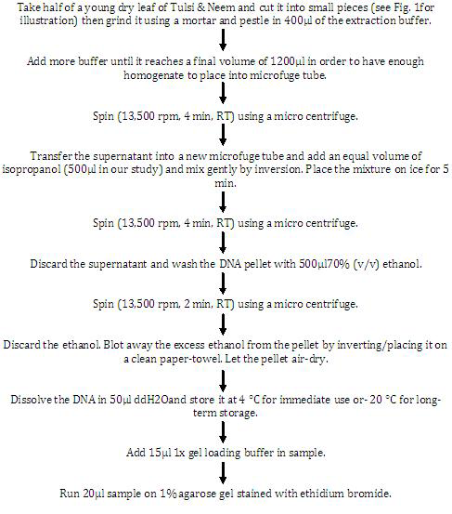

GRAPHICAL REPRESENTATION: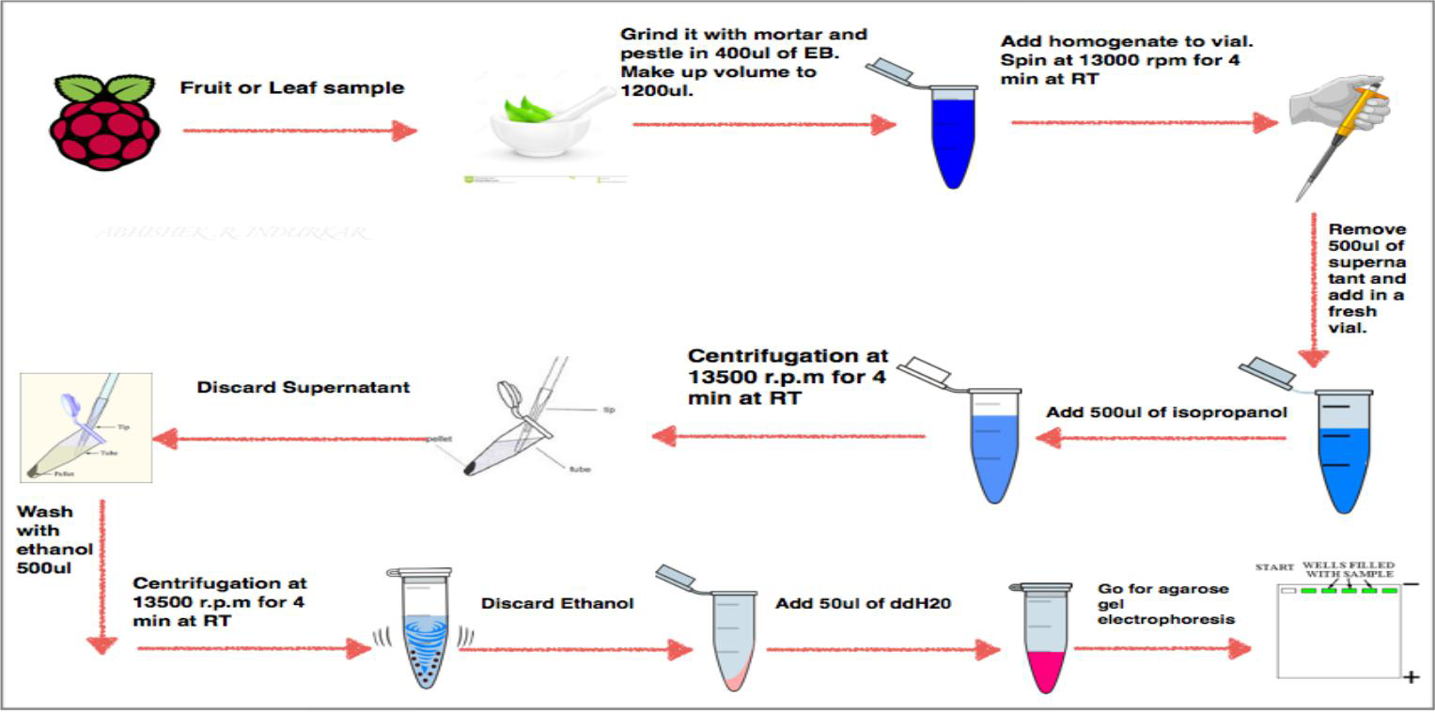

POST TEST :

1) How to isolate the DNA from given plant source?

2) What is the principle of Plant DNA isolation?

3) How to store the isolated plant DNA sample for long duration?

REFERENCES:

KIT Biotechnology engineering department S.Y. BTech